**Code Guide**

M. Pourfard, K. Faez, and S. H. Tabaian, "[Unsupervised Gabor Filter-Bank Method for Characterization of the Self-Assembled Hexagonal Lattice](https://www.scientific.net/JNanoR.31.40)," Journal of Nano Research, vol. 31, pp. 40-61, 2015 [**IF=0.532]** [**[Q3]**](https://www.scimagojr.com/journalsearch.php?q=17600155202&tip=sid&clean=0) **[**[**PDF**](https://www.researchgate.net/publication/274837738_Unsupervised_Gabor_Filter-Bank_Method_for_Characterization_of_the_Self-Assembled_Hexagonal_Lattice?_sg%5B0%5D=qBhIGb8uzW3v-7l_VLPS5uJOxy5AJStk4vDgSBOgxLmidPjNLpZNsfAPCi3CXZlwUpiV1s9p-uNx9o6TIuHOUMi71tvbqIKv85t_CIwR.vg4gVMF4RZjSq0AdEyPvoT5cD0YaWgBUJHxb1N1tP-FnEyWiN40fw8-s37QpfMyT2iV3YGufQjVjbvrF3bGQ8g)**]**.

If you have used the code you must cite the above paper.

Code Language: MATLAB

Date of code: 2015

Producer: Mohammadreza Pourfard

Email: [pourfardm@gmail.com](mailto:pourfardm@gmail.com)

**How to run the code?**

**The code is:** **gaborfilt.m**

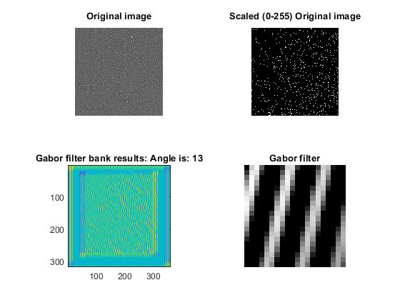

Figure 1 shows the gabor filter orientation

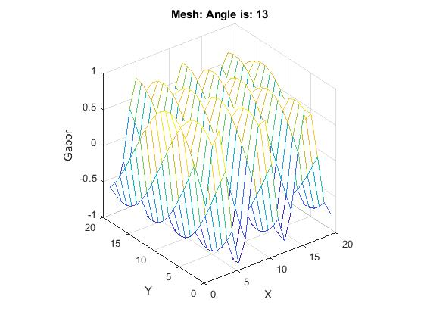

Figure 1 shows the 3d version of gabor filter in different orientations

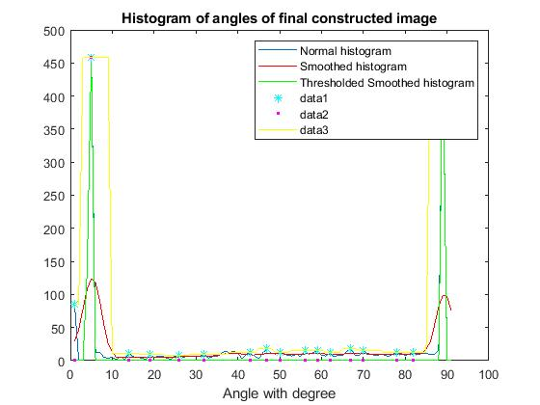

Figure 3 shows the result of gabor filter in different pore orientations. Then cut based on the peaks.

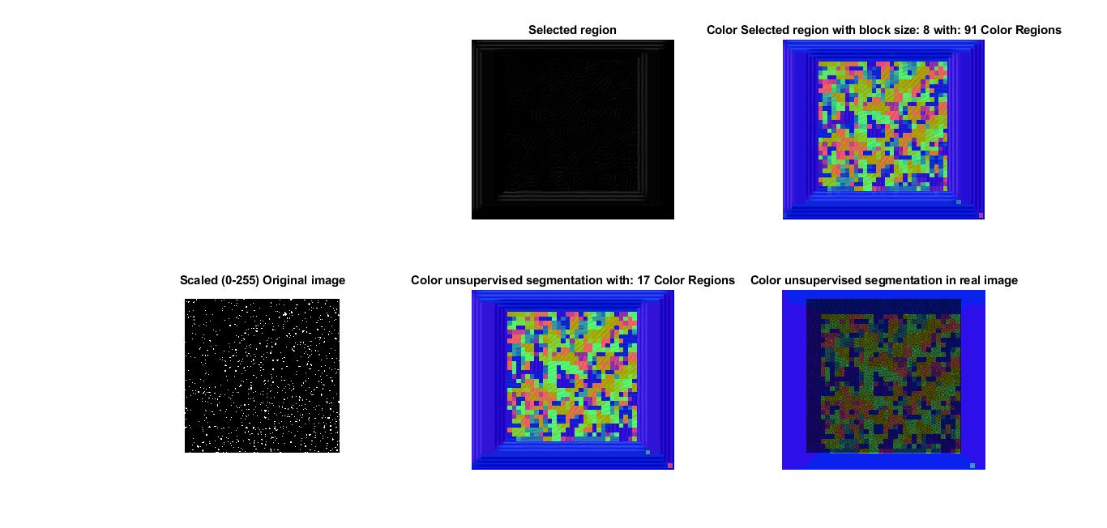

Figure 4 shows the result of segmentation